Amino acid as acid and bases
When an amino acid is dissolved in water, it exists in solution as the dipolar ion, or zwitterion.
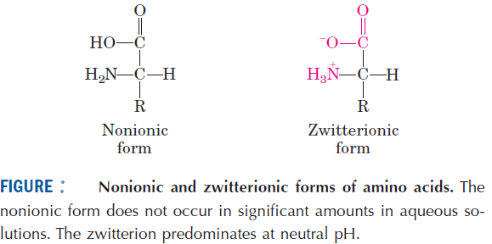

A zwitterion can act as either an acid (proton donor):
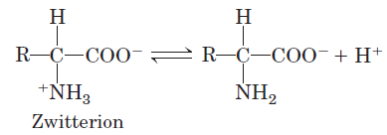

or a base (proton acceptor):

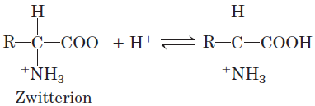

Substances having this dual nature are amphoteric and are often called ampholytes (from “amphoteric electrolytes”). A simple monoamino monocarboxylic α- amino acid, such as alanine, is a diprotic acid when fully protonated—it has two groups, the -COOH group and the -NH3 ⁺ group, that can yield protons:

